Symptom:
Diagnostic mode reports error 7:
Not in focus after 5x (no rotation of disc)

Test 1 – confirm FOC-EN from module R (drive processor)
At start up FOC-EN should be low and !FPI should be high
FOC-EN input to J is 7J1
!FPI input to J is 2J1
GND is 9J1
Test (module J removed): Confirmed, on start-up FOC-EN is low and !FPI is high

Once laser is on the drive checks FOC-IND is 1 (currently out of focus) – if true then FOC-EN should go high
When focus is gained !FPI will go low
Test (module J removed): On power up (diagnostic mode) FOC-EN goes low-high 5 times. !FPI is high and remains high

Once !FPI is low, FOC-IND should also go low indicating that focus is found. If FOC-IND does not go low, error 7 is generated

Test 2 – Check for Module J output on FOCACT (focus coil drive signal from J)
FOCACT output from J is 5J1
GND is 4J1
Note: 6210 and 6211 pin out in the service manual is incorrectly labelled. Should read ECB not BCE.
Test: On power up (diagnostic mode) there is 0V on the collector output from 6010 and 6011 and no activity.
7V on pin 7 of 7001-2B – no variation
D (drain) of 6206 – no variation @ 500mV sensitivity
S (sink) of 6206 – variation in 1-2V range
G (gate) of 6206 – variation in 1-2V range
Replaced JFETs with NTE312s – 6205, 6206 and 6211.
Test: FOC-ER input to module J –
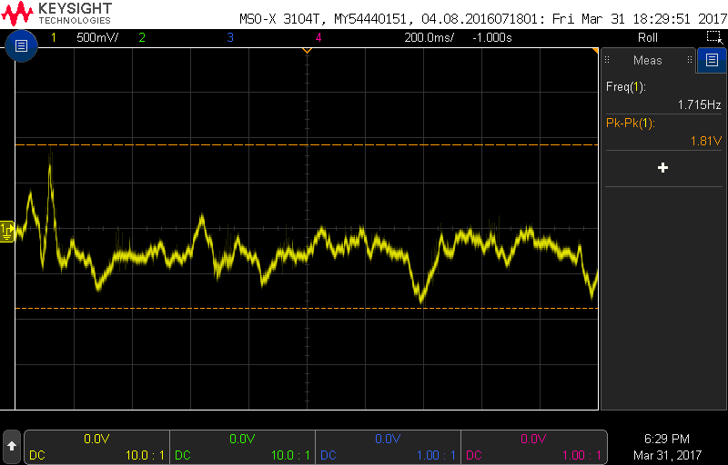
Small 1.81V P-P input on FOC-ER.

Test: Continuity between module J FOCACT output on 5J1 and 4J1 to objective coil in LDU.
Result: Continuity is good on both sides of the objective coil (<0.5 ohms). Resistance across the coil is 10 ohms
Test: Trace FOC-EN, !FPI and FOC-ER on module J. From start-up through diagnostic mode
Result:
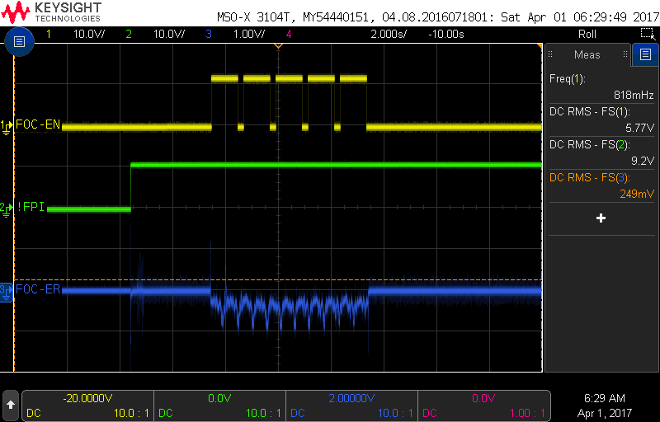
Test: Trace FOC-ER into module J to input on pin 6 of 7001-2B (MC1458P1) and !FPI on pin 5 of 7001-2B:
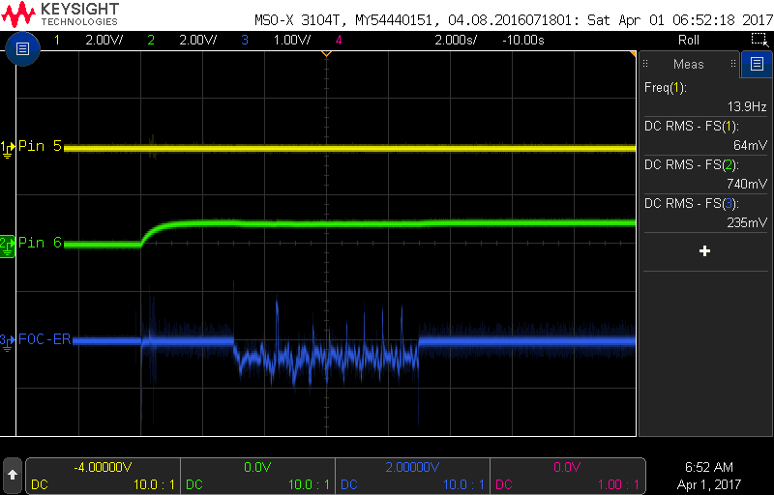
Test: S, D and G of 6206 on module J from power on through diagnostics.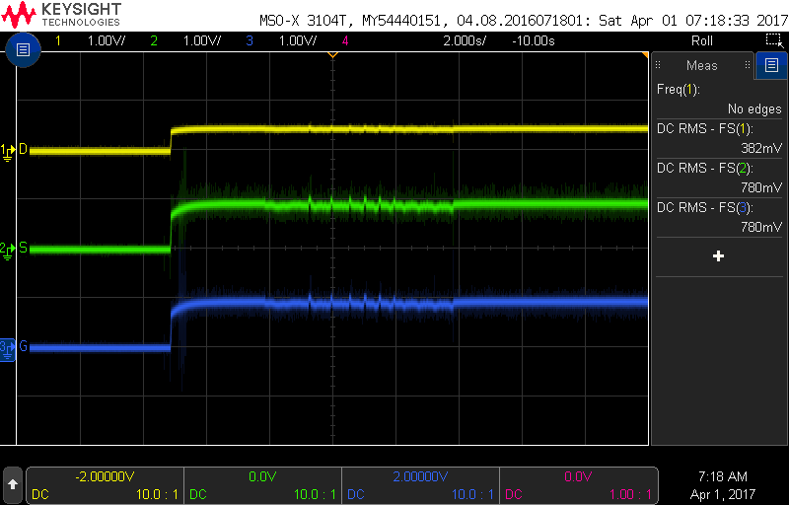
Test: check all capacitors on module J
Result: All capacitors look ok
Test: Replace all BC848 and BC858 transistors on J module
Result: No change
Test: check resistor 3003 – ok

Test: Trace pins 5, 6 and 7 of 7001 (MC1458P1 opamp)
Result

